For this task I have used one of the default dataset of Plotly Python library., The dataset is gapminder, which includes statistics and other information about social, economic and environmental development at local, national and global levels.

I have used pandas library for data manipulation and Plotly library for data visualization

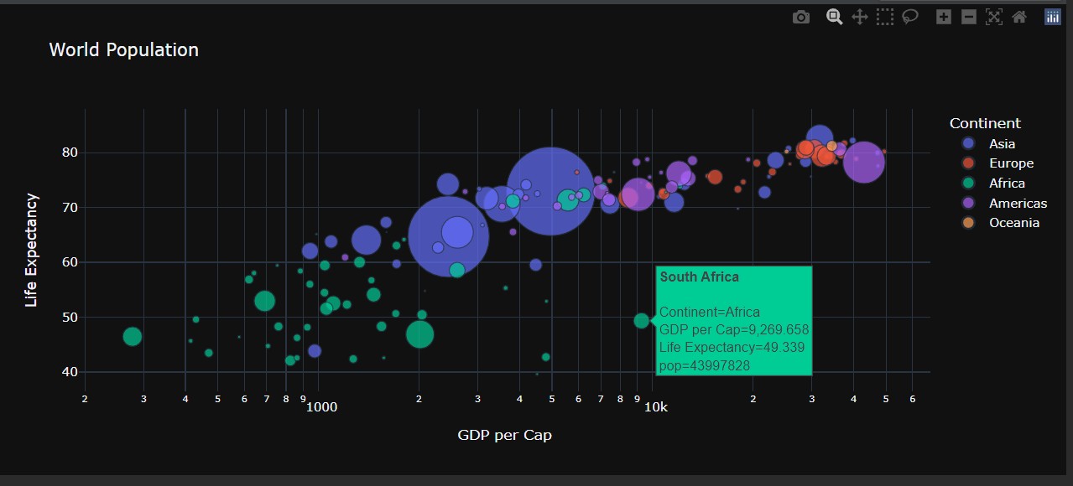

The above graphics shows world population data grouped by Continents regarding GDP per capita and Life Expectancy.

I have used the query method of thepandas lybrary to select data for top 6 country regarding the population, gdp and life expectency.

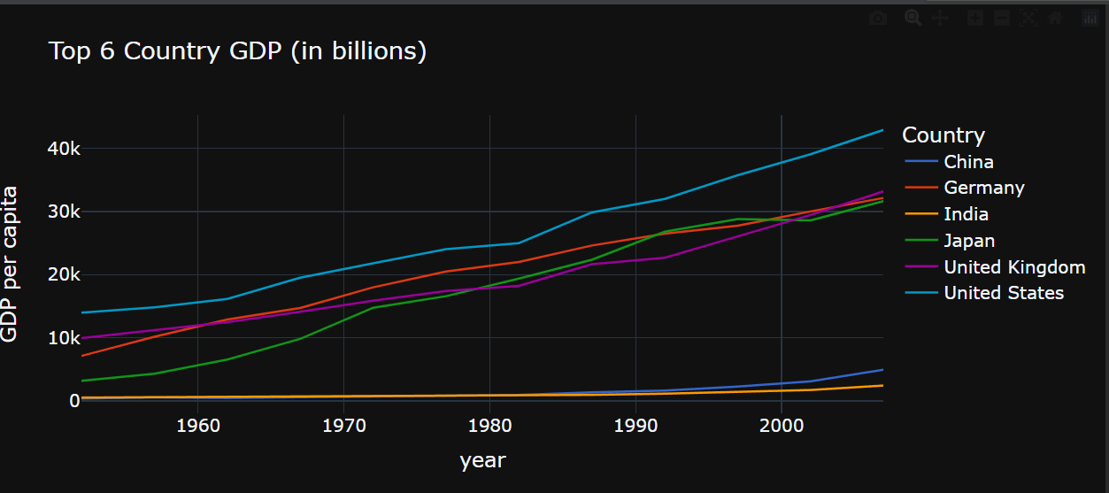

The above chart shows GDP per capita for period 1952 to 2007, the USA is the country with highest GDP per capita, also we can see the rise of Germany and Japan GDPs., nowdays China should be the country with the second highest GDP after the USA.

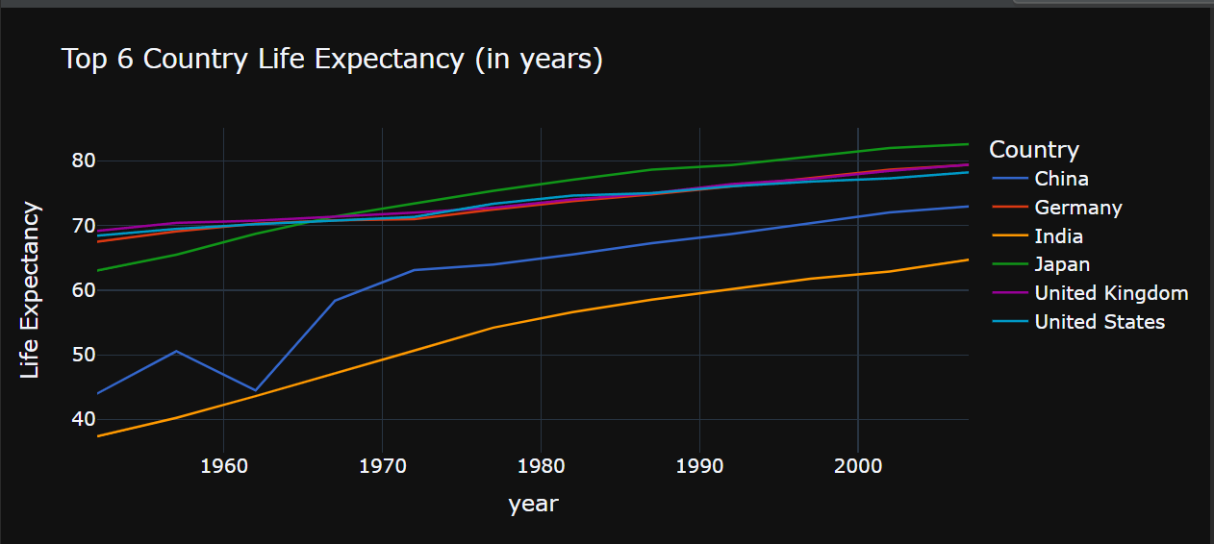

The above chart shows that the Japan is a country with highest Live of Expectancy (in years

). In 1952 the Live of Expectancy in Japan was 63 years which increaset to 82 years in 2007. Also we can see significant increas of Live of Expectancy in China for the period of 1952 to 2007.

For better visualization and presentation I have used animated image which has been implemented with choropleth plot of plotly express lybrary.

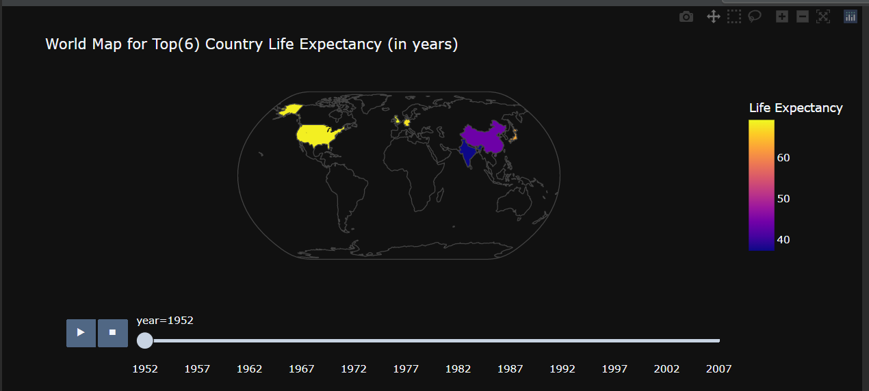

The above plot shows the Life Epectancy in years for eact country and the location in the world map for eact country of the top 6. ( the plot has been exported as static PNG image)

Benjamin,

Also, I would have been interested to see the size of the default amount of the loans with the same income between the education group.